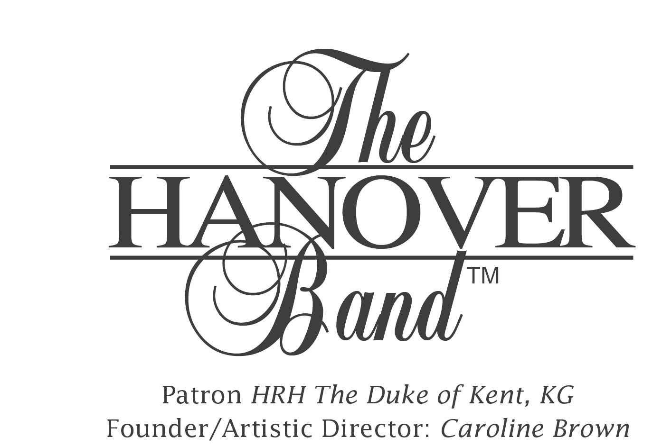

THE HANOVER BAND

“All the colours…registered vividly on the period instruments, and Bayl steered this familiar music with fresh imagination.”
THE TELEGRAPH, ST JOHN’S SMITH SQUARE (ROSSINI ‘STABAT MATER’)
“The Hanover Band’s gutsy playing stripped decades of varnish from the score with sound that was full-blooded…”
THE TIMES, EDINBURGH FESTIVAL

The Hanover Band was formed in London by Caroline Brown in March 1980 and has an international reputation for the excellence of its performances and recordings of 18th and 19th-century music.

It performs, records and undertakes education work regularly in the UK and has toured throughout Europe, USA(East and West) Canada and Mexico, appearing in prestigious festivals and venues such as the Haydnfest, Eisenstadt Austria, Concertgebouw Amsterdam, De Doelen Rotterdam, Berlin Philharmoniesaal, Cadogan Hall, Royal Albert Hall, London (BBC Proms), Usher Hall, Edinburgh and Bridgewater Hall, Manchester; Carnegie Hall & Lincoln Center New York, Harvard, Princeton Universities and UCLA Los Angeles, USA. The orchestra’s list of directors over previous years, reads like a Who’s Who of period instrument interpretation: Monica Huggett, Sir Charles Mackerras, Roy Goodman, Anthony Halstead, Nicholas McGegan, Andrew Manze, Richard Egarr, Nicholas Kraemer, Paul Brough, Andrew Arthur, Benjamin Bayl and Mahan Esfahani.The Hanover Band Chorus who regularly work with the Band are comprised of leading choral specialists, who are actively working in the early music world.

The orchestra’s impressive discography of 176 commercial CDs includes an award-winning Beethoven cycle (Nimbus Goodman), Donizetti’s Lucia di Lammermoor (Sony Mackerras), Handel’s Serse (BMG McGegan), Bach Brandenburg Concertos (EMI Halstead),Weber Horn Concertino (Halstead Nimbus) Bach Cantatas, Mozart Clarinet Concerto (Nimbus/Lawson), Handel Opera Arias with Natalie Stutzmann (BMG), Beethoven and Mozart Violin Concertos with Stephanie Chase (Cala), Haydn Symphonies (Hyperion Goodman), the complete orchestral works of JC Bach (Cpo), Boyce’s Ode for St Cecilia’s Day, Secular Masque, David’s Lamentations over Saul and Jonathan and 18th century British symphonies (Lea Coz/ASV), Schumann Symphonies (BMG), Sullivan’s Rose of Persia and Overtures (Cpo), Mozart Arias, The Supreme Decorator (Opera Rara Mackerras) and their recently released Hyperion CD of Mozart’s Horn Concertos with Pip Eastop natural horn, conducted by Anthony Halstead.

This season the Hanover Band will debut at the Bejing Festival under Benjamin Bayl and, at the invitation of His Royal Highness The Duke of Kent, will perform with Danielle De Niese at Buckingham Palace in June to launch the Band’s education initiative ‘Nurturing The Next Generation’.

Dated June 2017

